Lab number: 1

Lab Title : Link load and bandwidth

### Abstract:

### *Familiarise myself with the ns2 program for simulating networks, then look at how the nodes transmit data to one another before implementing an additional node in addition to changing the size of the queue for node 2*

### Aim objectives and goal:

*Become used to ns2 and observe what happens when the nodes transmit to other nodes.*

### Observation/ Results and Discussion:

*When node 1 transmits the packets from the cbr generator to node 2, it is transmitting it in fixed and consistent intervals of 8 nanoseconds with 1000 bytes in each packet whilst when node 0 is transmitting data packets from the ftp generator to node 2, it has more irregular patterns as it is sending packets according to the ACK packets it receives from the sink agent in node 3. When both nodes transmit packets at the same time, some of the packets start dropping once they reach node 2.*

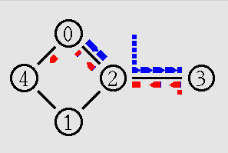

*After updating the topology, I noticed that node 1 was being ignored by the simulator. I presume this is because there is no need to send the packets through two nodes at once as one is enough to send the data, so the simulator has determined node 0 is the optimal node to use in its simulation. I also changed the queue size for node 2 to 1 and 5 – only cbr packets were being sent from node 3 and on a queue size of 5 there were a lot more ftp data packets being sent within a very short amount of time of each other.*